|  |  |  |
| --- | --- | --- |
| **LAB 321 Assignment** | **Type:** | **Long Assignment** |
| **Code:** | **3** |
| **LOC:** | **500** |
| **Slot(s):** | **12** |

**Title:** Northwind Product

**Background**

**Northwind** Traders database is a sample database that shipped with Microsoft Office suite. The Northwind database contains the sales data for a fictitious company called Northwind Traders, which imports and exports specialty foods from around the world. Northwind is like a real world database but the names of companies, products, employees, and any other data used or mentioned do not in any way represent any real world individual, company, product, etc.

**Program Specifications**

Program a web site to manage product list, detail functions will be described below

**Features:**

This website contains following main functions

* Function 1: Product list
  + Display the list of product, the product list are devided by pages of 20 product
  + Each product contains
    - Product ID
    - Product name
    - Supplier link – Get from Company name table Suppliers
    - Category – Get from Category name table Catgeories
    - Quantity per unit
    - Unit price
    - Unit in stock
    - Unit in order
    - Discontinued
* Function 2 : Edit product list
  + Edit batch of products
  + User select list of product to edit, site will redirected to a page to allow user to edit multiple product in a page
  + Supplier and category is dropdown list select items from Suppliers table and Categories table
  + Click save to save edited data to product table

This is function for admin control panel, you can add data manually (use SQL SERVER Management studio).

Note: All data must be load from database, not hard code in page.

Pic 01 : Database description

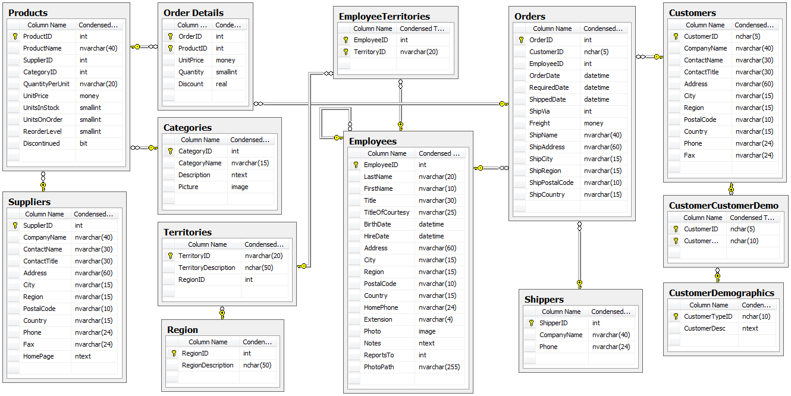

***Expectation of User interface:***

PIC 1 : Product list

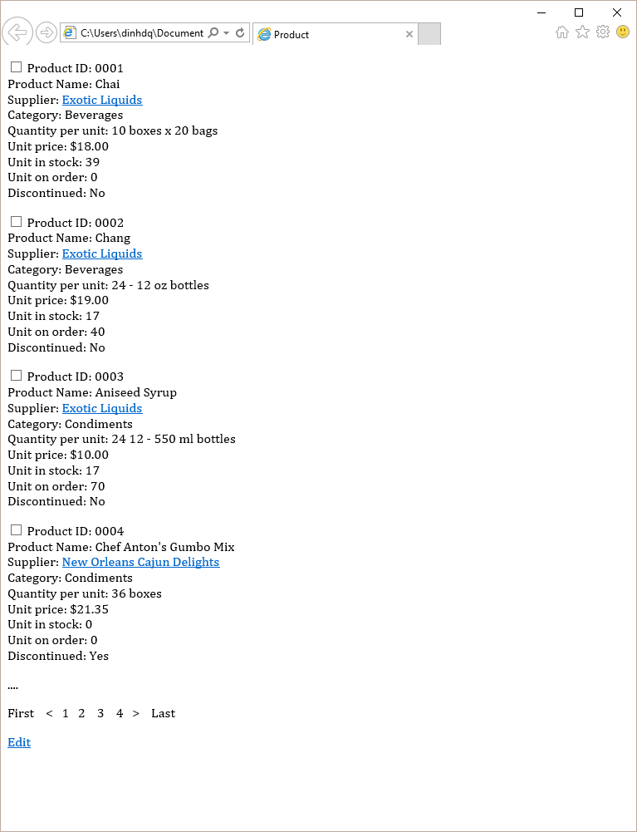

Pic 02 : Products edit

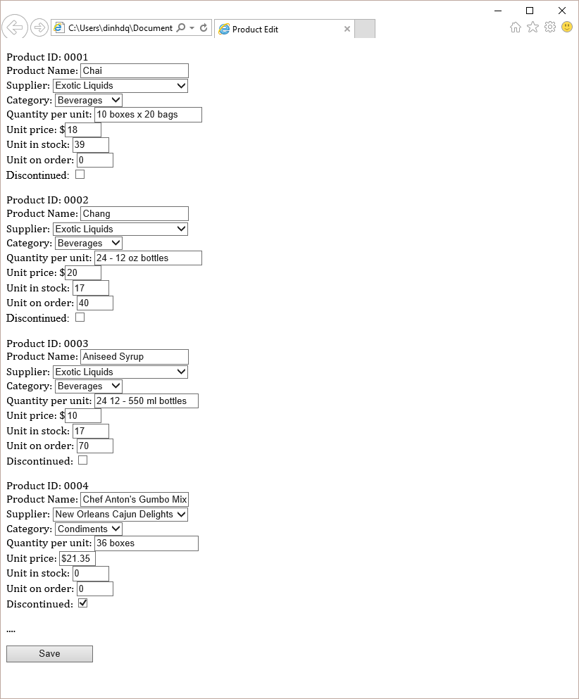

**Guidelines**

* Step 1 : Create web layout
* Step 2 : Create prototype
* Step 3 : Design database base on created prototype
* Step 4 : Code & Test